Report

On

7 DAYS National E-Workshop
On
“Sanskrit Research Methodology”
organized by

Department of Sanskrit, Chakdaha College (Affiliated to University of Kalyani), Chakdaha, Nadia, West Bengal, India
In Collaboration with
Department of Sanskrit, Srikrishna College, Bagula, Nadia, West Bengal, India
Department of Sanskrit, Hijli College, Hijli Co-operative, Paschim Medinipur, West Bengal, India

Report Submitted by: - Rajib Sinha
Designation:- Assistant Professor & Head
Department:- Sanskrit , Srikrishna College, Bagula,
Nadia,West Bengal, India, 741502

Abstract
The monstrous virus Covid-19 has shaken the whole world. It has brought uncertainty, fear, social distancing, economic instability, depression and so many crises in our life. This situation is hampering research around the world. In this connection this type of academic engagement is important and inevitable for our existence. Actually creation and dissemination of knowledge through research is one of the core functions of the higher learning institutions. Apart from generating new knowledge, the higher learning institutions have the responsibility of training the intellectual manpower required for all sectors of the society. Quality of manpower is the most important factor for producing good quality researches. With the passage of time, various institutions continue to carry their own important role and improved methods in improving the quality of research. But in the current Corona atmosphere, research work is being hampered due to various reasons. This has raised a concern among the academic community, social thinkers and policy makers. Amongst all other factors, training of the researchers is the most crucial one. We need to think about how young researchers can do research independently without relying on anyone. To improve the situation there is a need for providing training on research methodology to the young scholars. The present workshop is an endeavour in this direction. The present workshop will focus on the following broad themes
Research can be defined as an activity that involves finding out, in a systematic way. To pursue a quality research, one must be well aware of the methodology involved in it. This Research Methodology course is designed for scholar intent in researching in the field of Sanskrit. The aim of this course is to familiarize the students with various aspects of Research Methodology. This will enable the students to organize and conduct research in an appropriate manner.
Objectives -This workshop will enable the students to
- Understand the discipline specific concepts of research and its methodologies
- Select and define appropriate research problem and parameters
- Organize and conduct research in systematic manner
- Understand the process of writing research report and thesis

Program approved letter by Srikrishna College & Chakdaha College
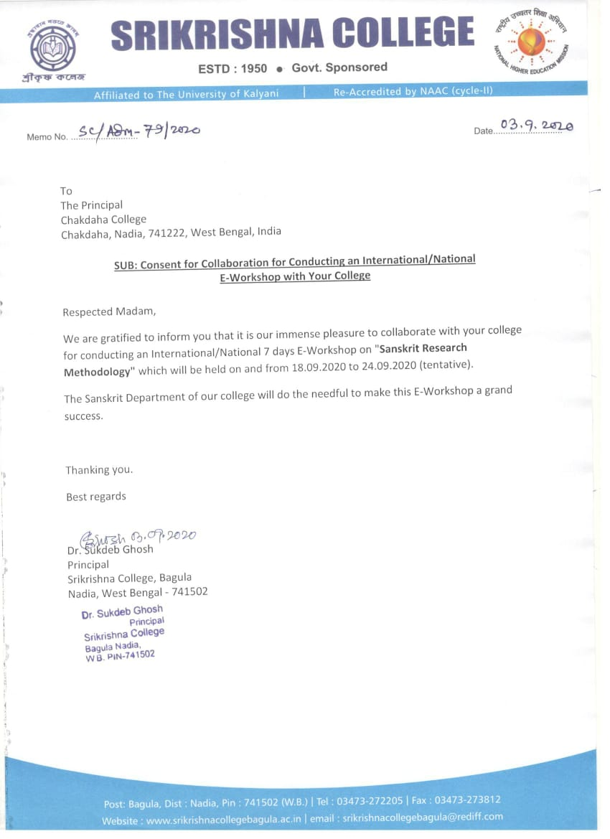
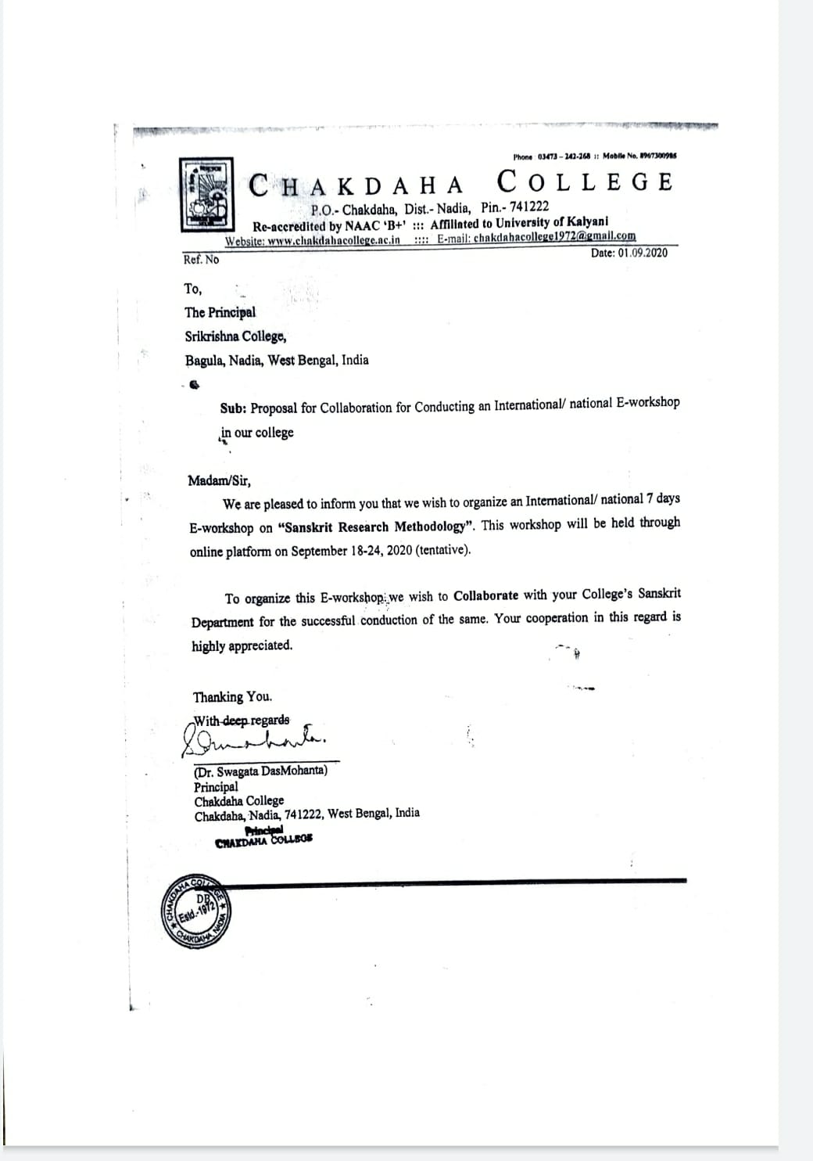

Cover page of the Program & Program schedule:
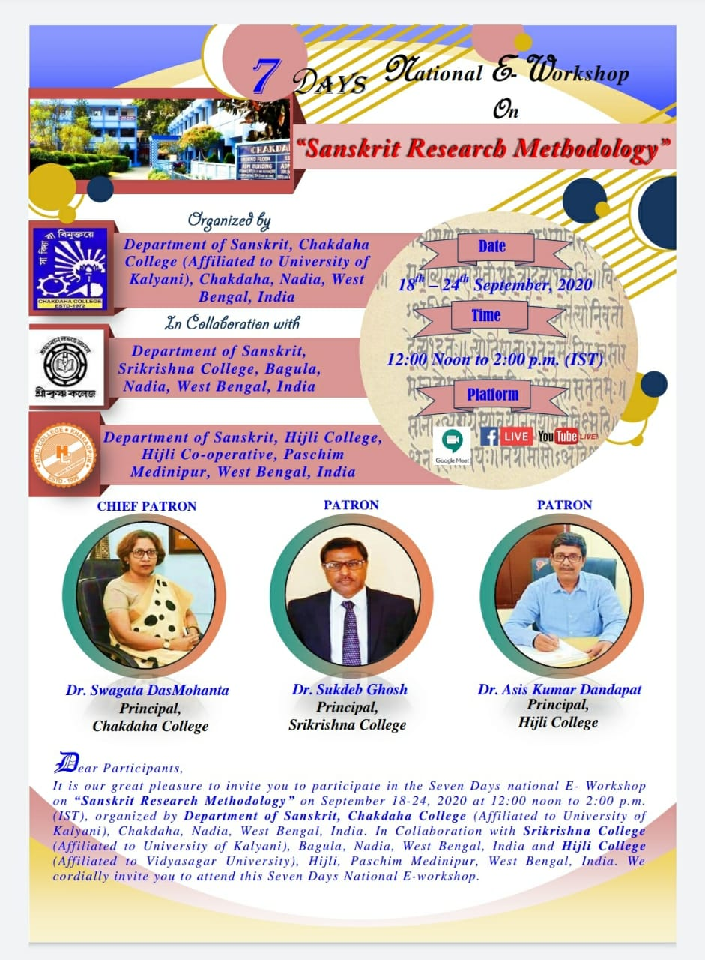
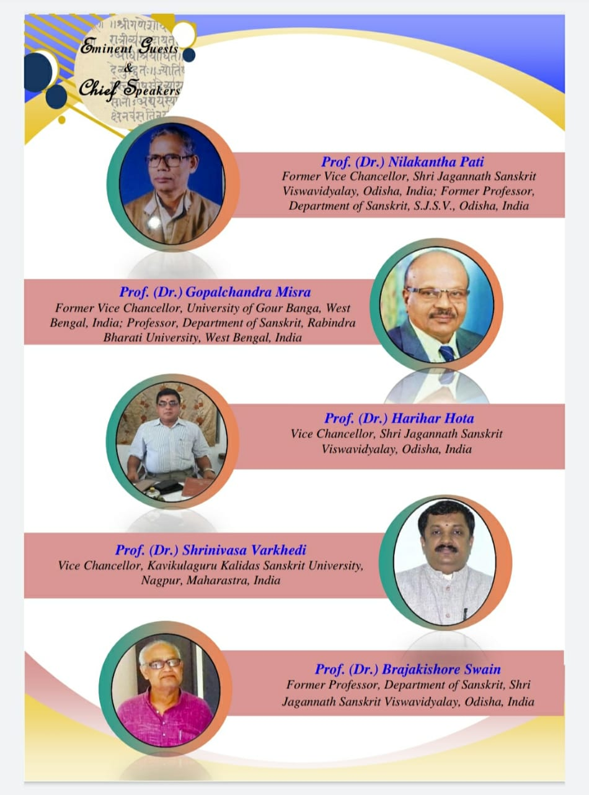
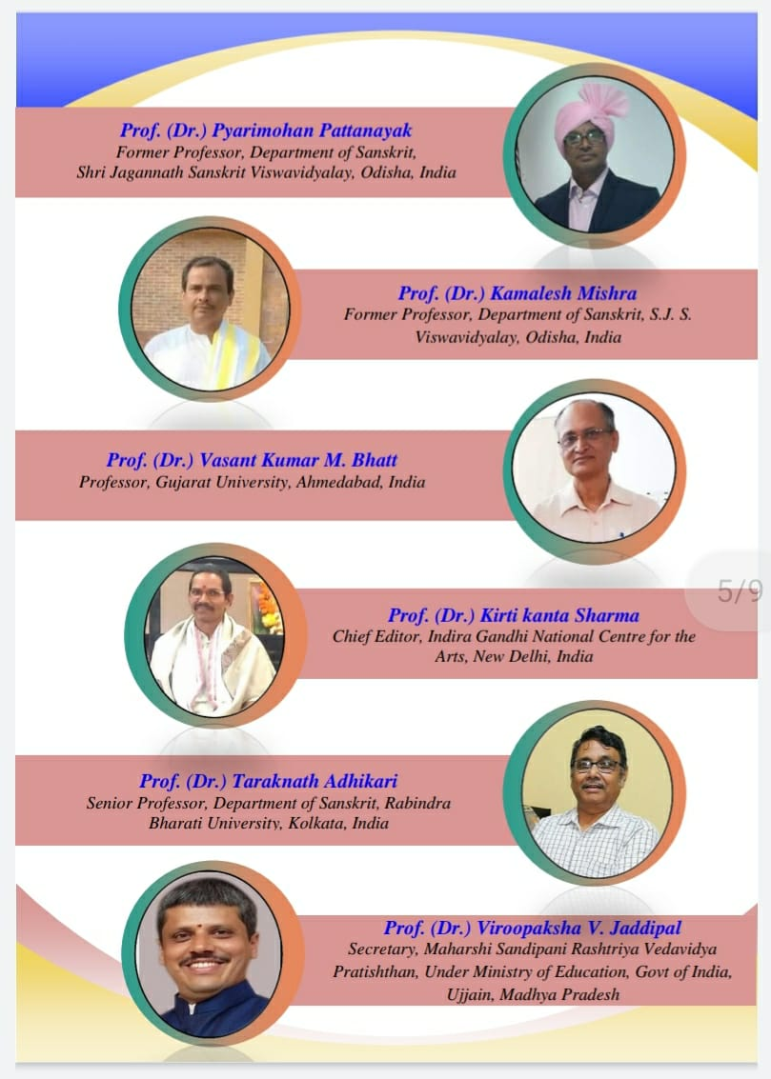

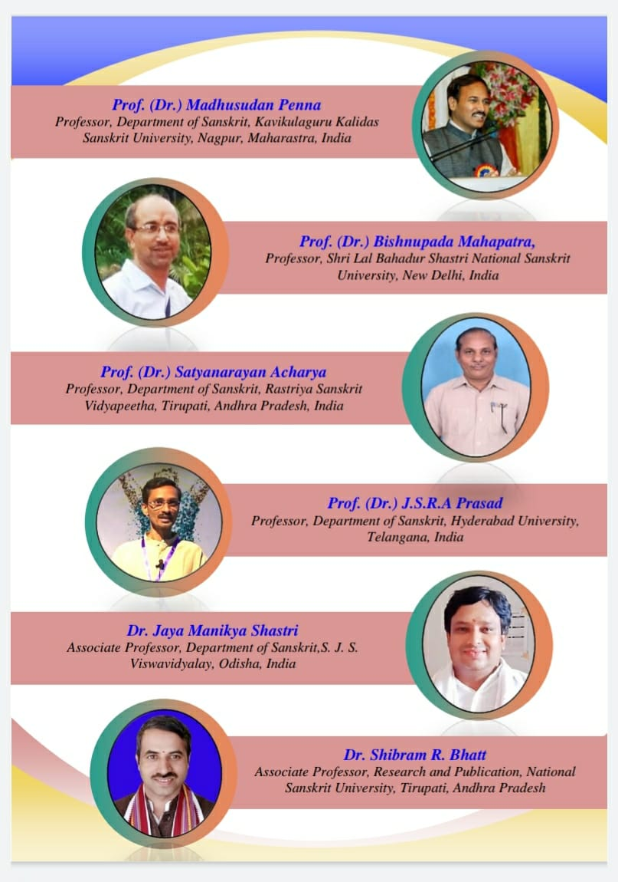
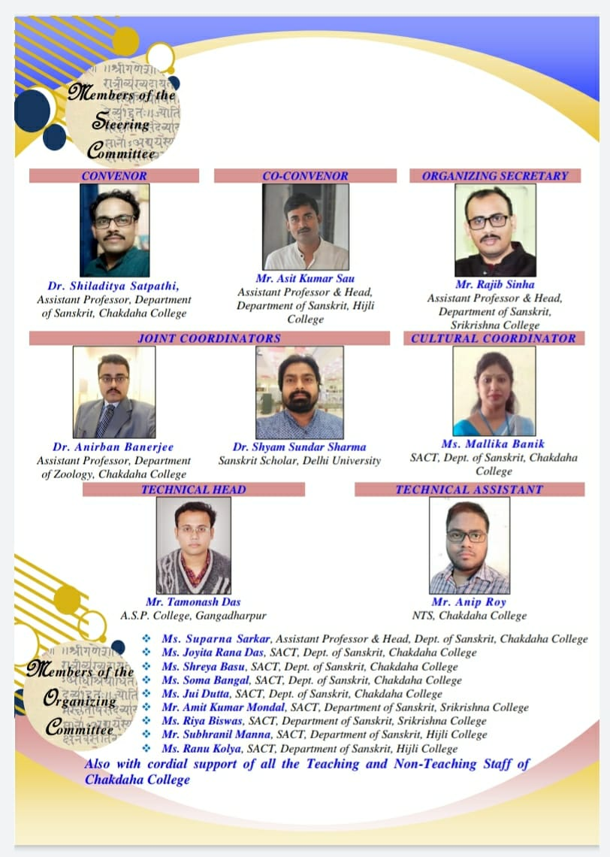

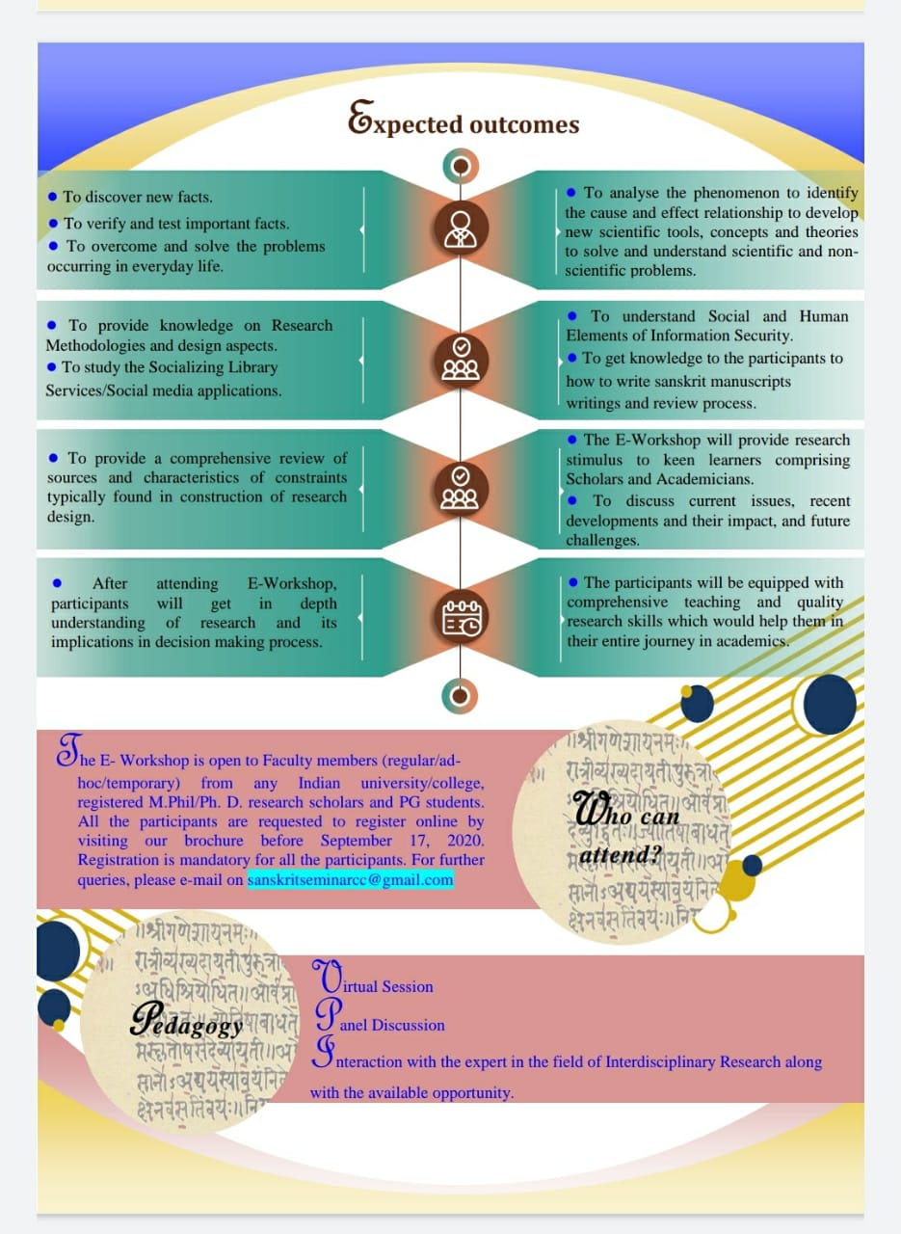
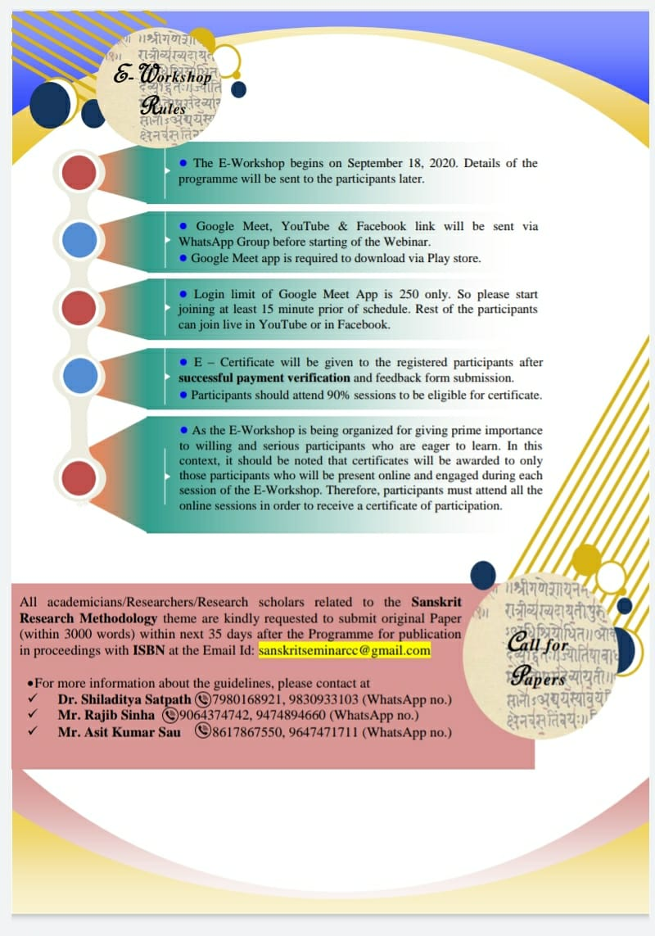
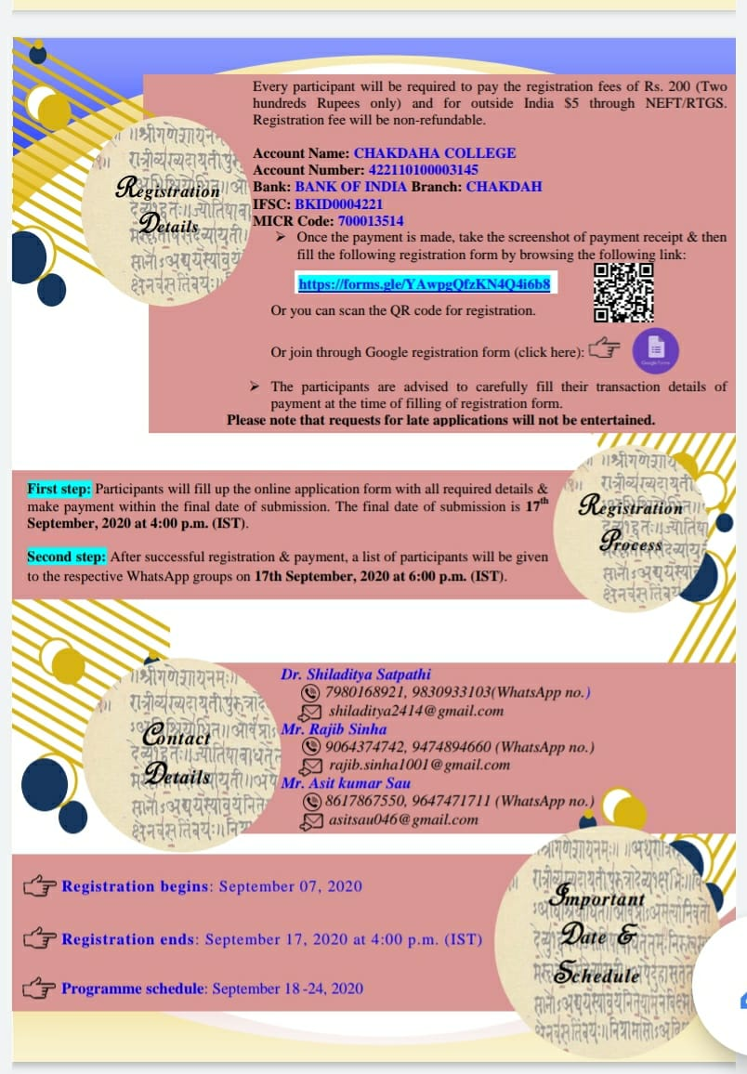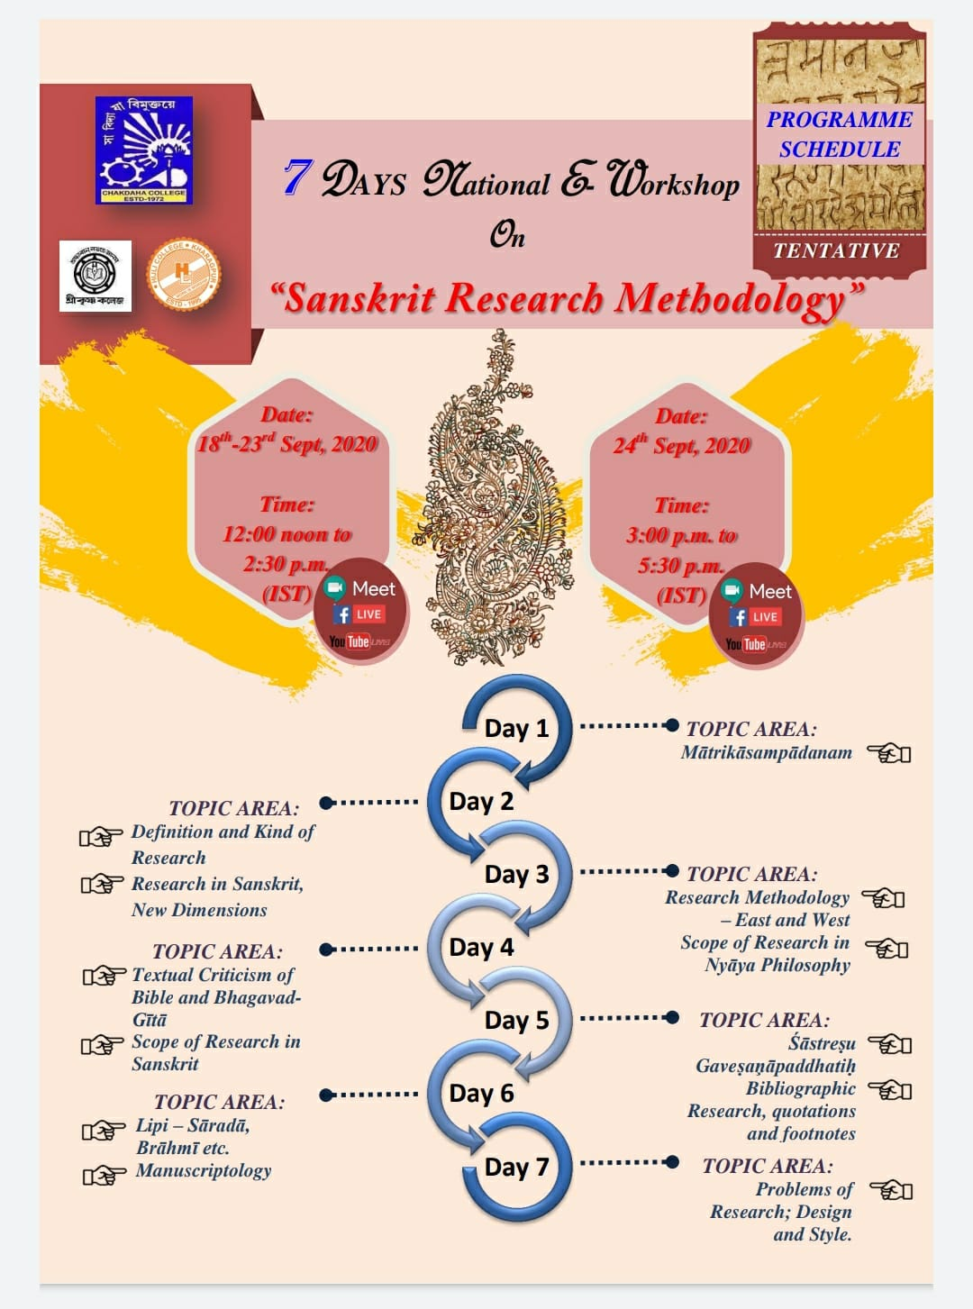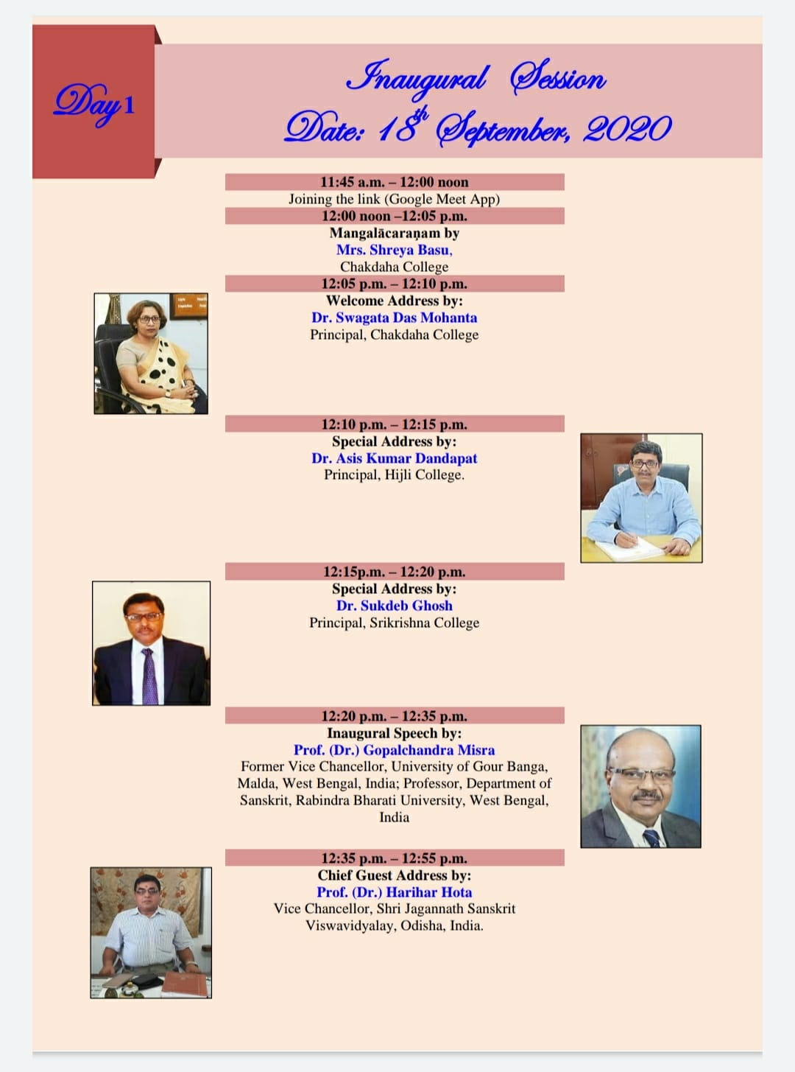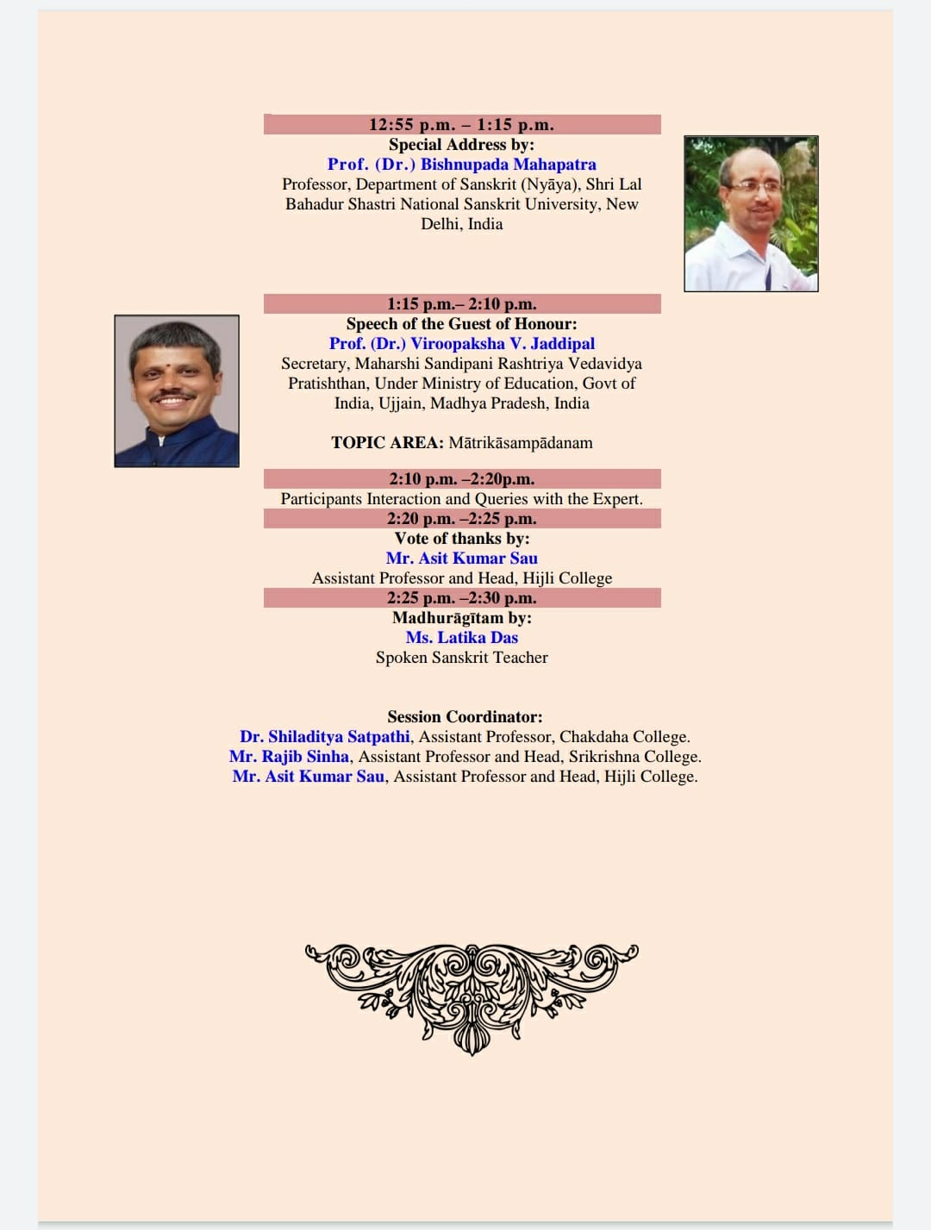
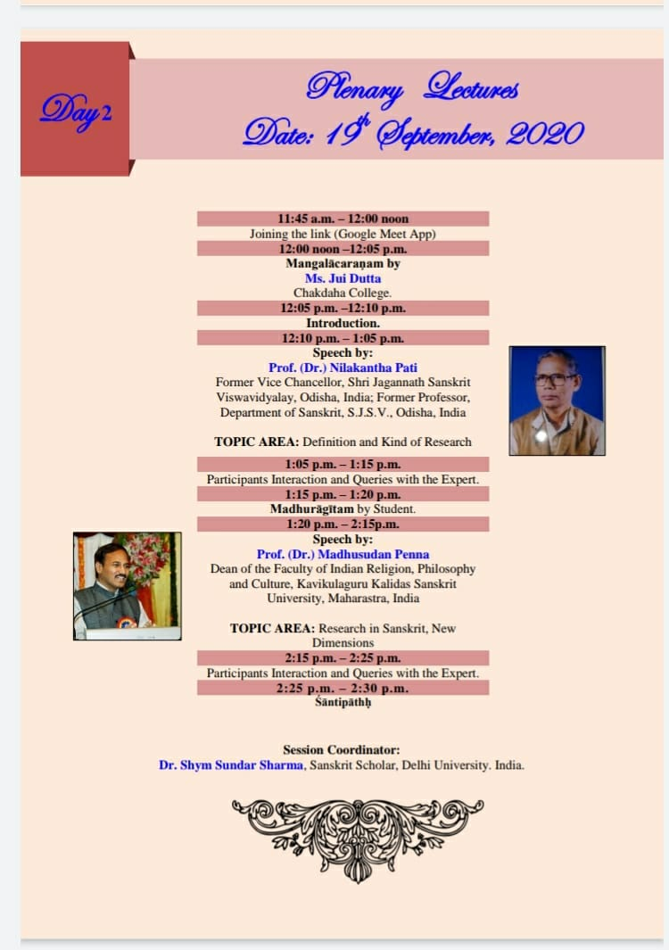

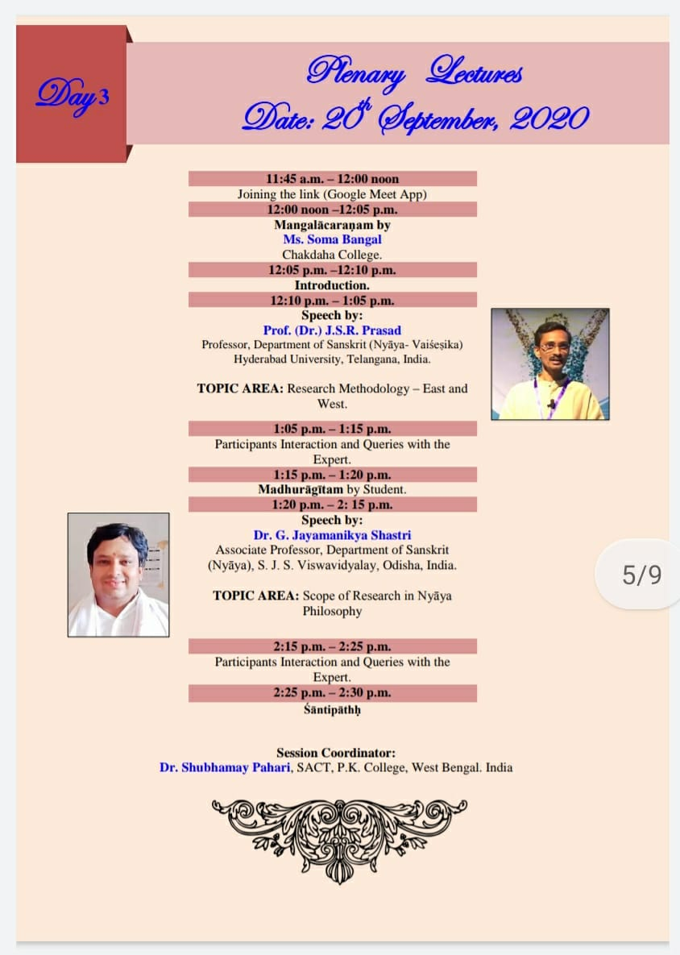

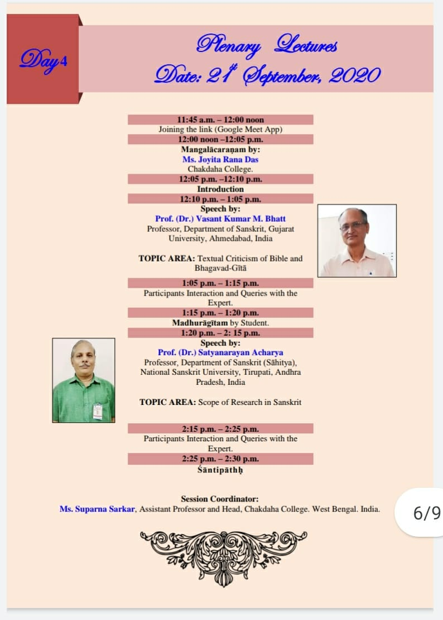

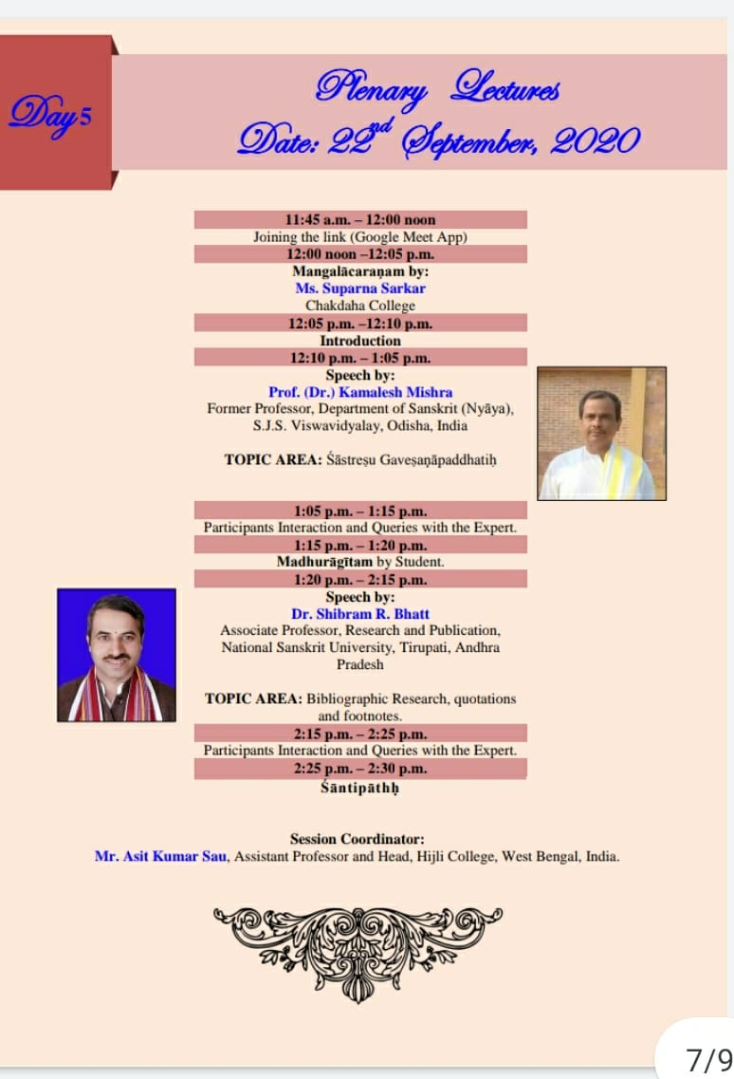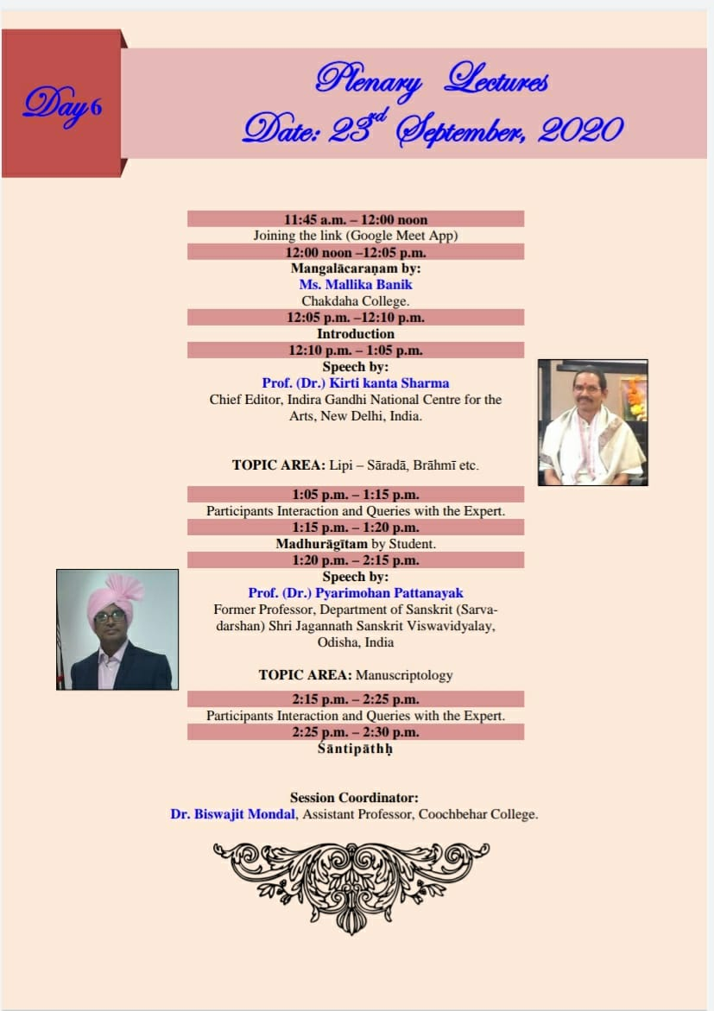
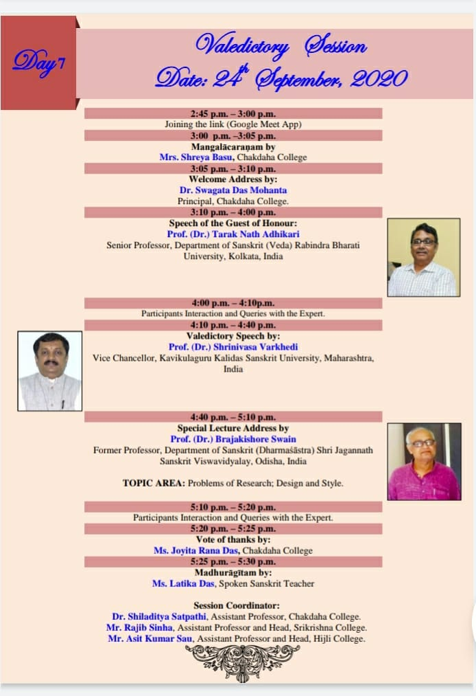

Some pictures of the Programme & Sample Certificate copy

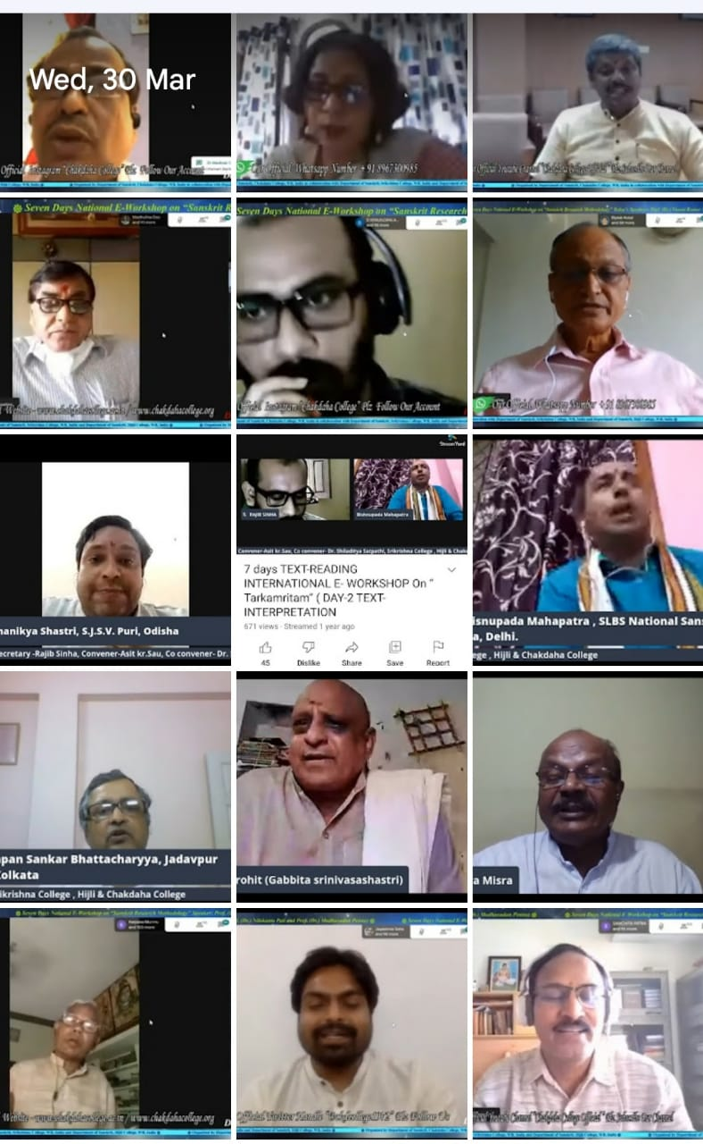
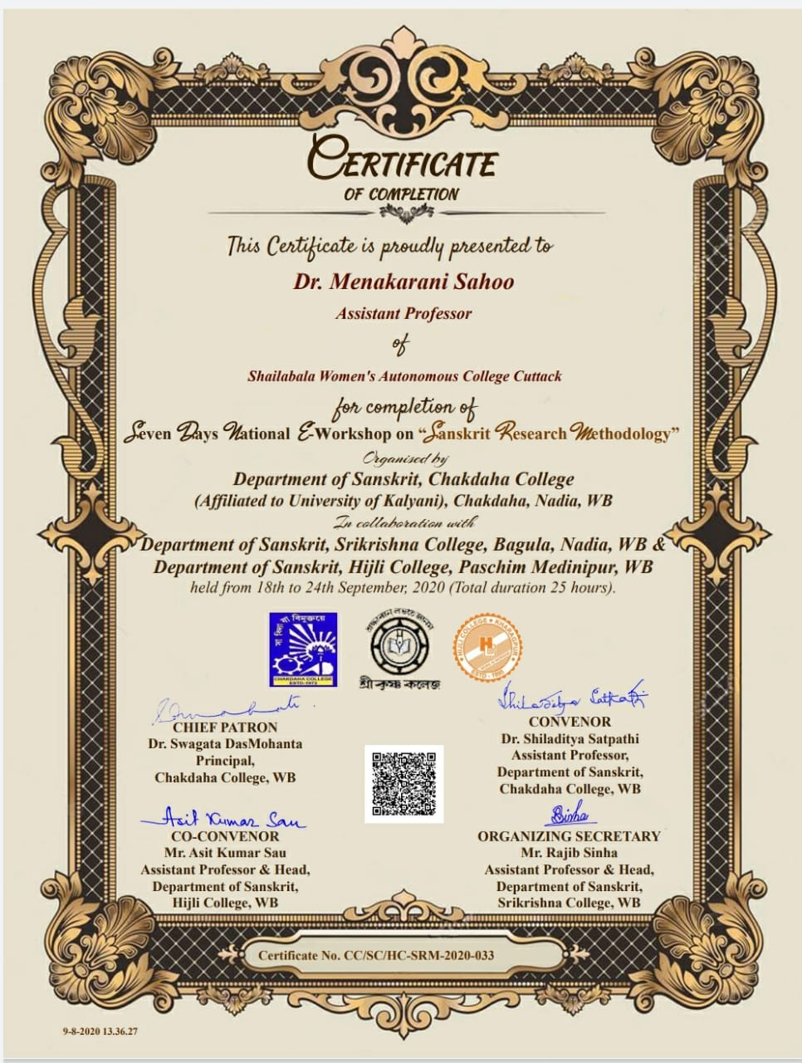 Participants profile:
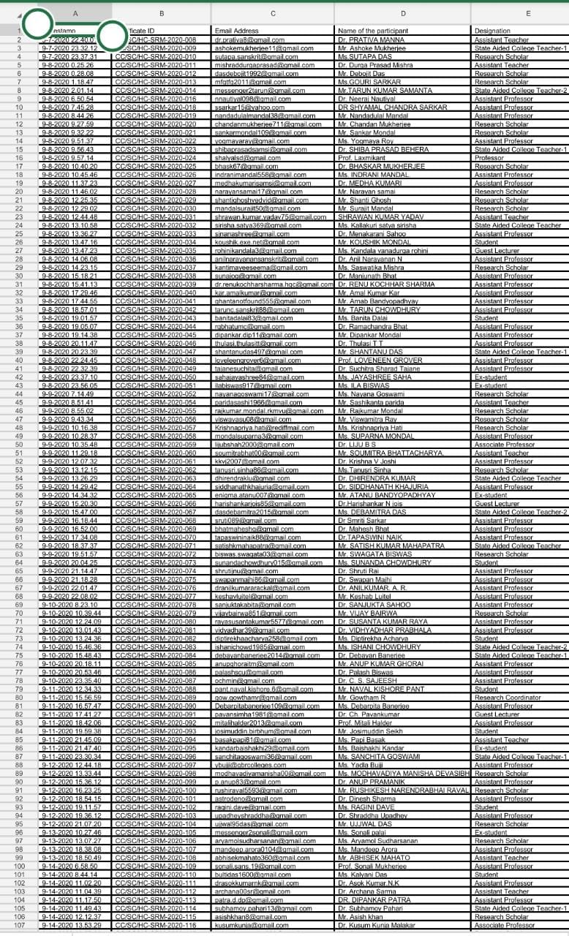
Recorded links:

Day-1- https://youtu.be/plE2fV1Mf68
Day-2- https://youtu.be/6rl5epNeNVY
Day-3- https://youtu.be/v3bDDK-UPjE
Day-4- https://youtu.be/AC6cmhOTlW4
Day-5- https://youtu.be/JZjjokdk8uQ
Day-6- https://youtu.be/kcYULykvuxM
Day-7- https://youtu.be/dk1FRaA6RK0

